General Results
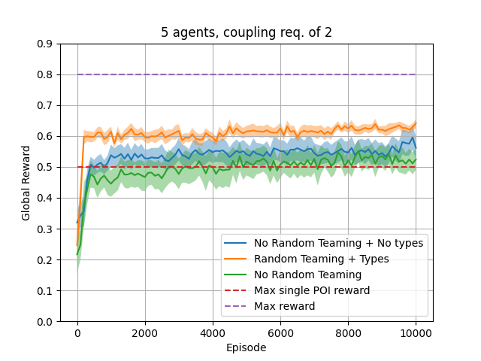

orange: this method
blue: each agent has separate policy
green: agent types, but no shuffling

scoring: avg of 50 runs of policies shuffled

3 types, 5 agents, coupling req of 2.

high ratio of types to agents
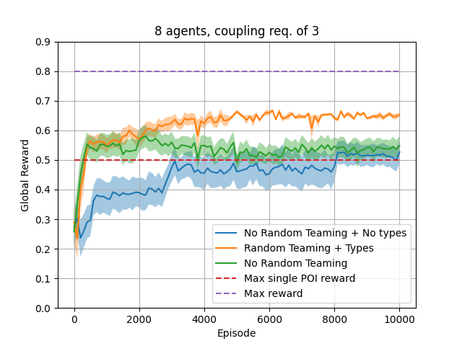
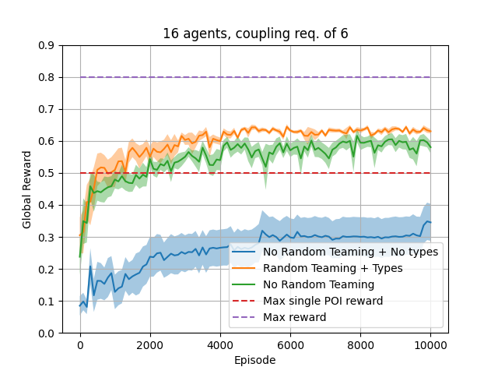
small improvement in performance

3 types, 8 agents, coupling req of 3.

still only 2 poi can be observed

no performance decrease from this method

3 types, 16 agents, coupling req of 6

no performance decrease from this method

Agent types show improvement in performance
potential effect of ratio of #types to #agents
potential effect of shuffling

Varying Algorithm Parameters (shuffle freq and # of types)
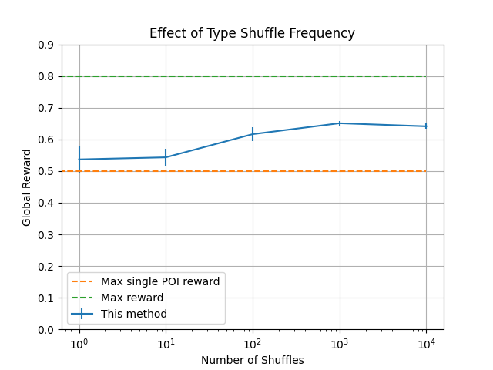
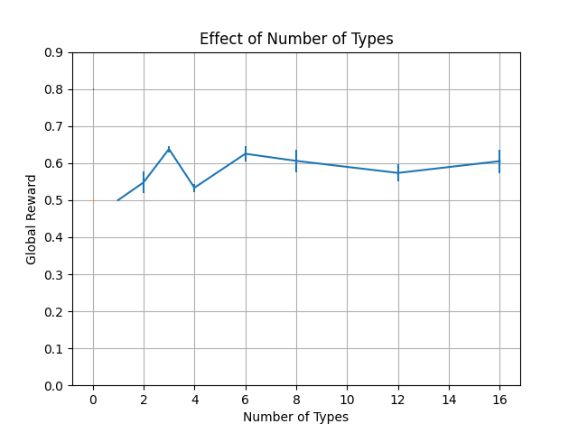
Argument: larger number of teams to learn in leads to more robust policies

shuffling policies simulates variety of teams

experiment: vary how many times the types are shuffled among the agents over 10,000 runs

results: more shuffling = more robust

Argument: Having fewer agent types means having to learn fewer interactions, which helps improves overall robustness.

Experiment: vary the number of agent types to be distributed among 16 agents

Results: 3 agent types performs well consistently, adding more types does not improve results

Also, too few types is detrimental
Sanity Check

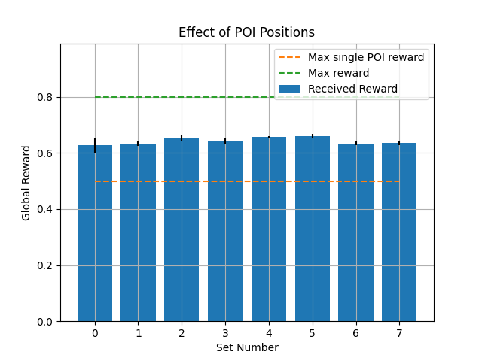
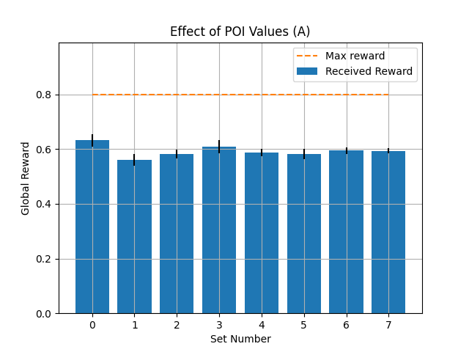
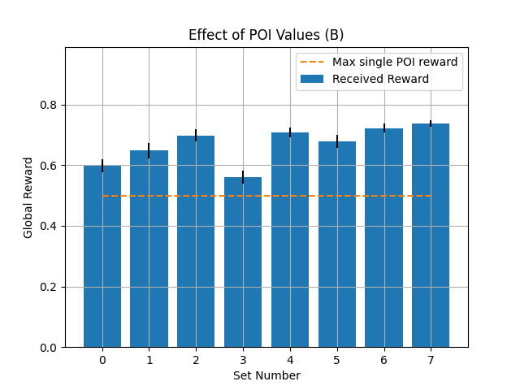
Experiment: Assign 8 sets of random x,y locations to the POIs

Purpose: Determine effect of POI location on learning performance

Result: Very little effect. Algorithm can be robuts to environmental variable

Experiment: Assign 8 sets of random values to the POIs

Purpose: Determine if ratio of POI values effects learning performance

Result A – rewards scaled to share same max reward: More variance but still not very high.

Result B – rewards scaled to share same max single POI reward: Agents consistently observe more than just the largest POI

